Week 8 Final Internship Documentation
Infosys Springboard Internship | Data Visualization Domain
Topic Focus: Final Dashboard Creation, DAX Practical Implementation, and Business Insights
Prepared by: Hindu Priya Boddu
Project: Optimizing IT Support Team Performance Using Analytics


1. Introduction
Week 8 is the final and most important stage of the internship because it focuses on converting all the learning from previous weeks into a complete Power BI dashboard solution. During this week, the cleaned support ticket dataset was used to implement DAX practically, create real project-specific measures, define calculated columns where needed, build a Date table, apply time intelligence basics, and design the final interactive dashboard.
This week combines technical implementation with business presentation. It includes dashboard visual creation, slicers, filters, drill-down, visual interactions, formatting, and storytelling. It also documents the challenges faced while creating the dashboard and highlights the key business questions that the dashboard answers for the company.

2. Final Project Workflow
The final dashboard creation followed a structured workflow. The dataset was first cleaned and prepared in Power Query, then modeled for analysis, followed by DAX measure creation, visual development, interaction setup, and insight extraction.
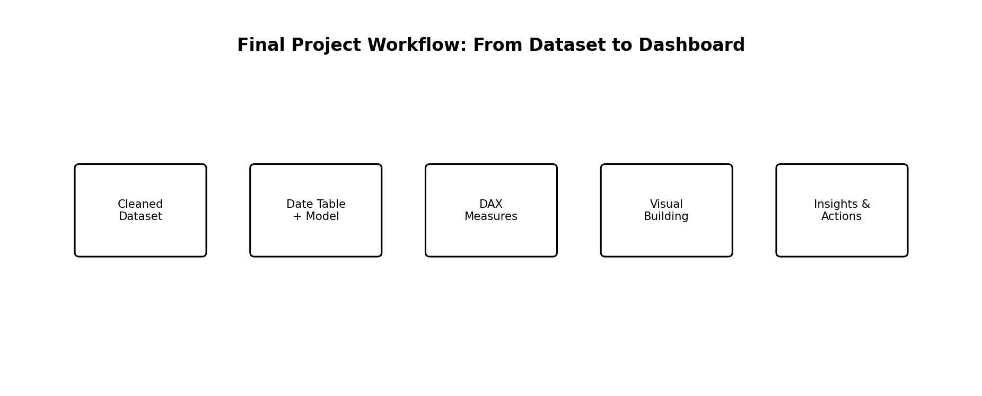
Figure 1: Final workflow used to convert the support ticket dataset into a business-ready dashboard
- Load the cleaned support ticket dataset into Power BI
- Verify data types and final quality checks
- Create a Date table for time-based analysis
- Create DAX measures and selected calculated columns
- Build KPI cards and analytical visuals
- Add slicers, drill-down, and interactions
- Format the dashboard for clarity and storytelling
- Validate insights and business questions answered

3. DAX Practical Implementation – Student Performance Dataset
In this project, DAX was applied directly to the student dataset to create meaningful and reusable measures.
The goal was to analyze student performance, identify influencing factors, and support decision-making through an interactive dashboard.
The measures focus on:
- Overall performance
- Subject-wise analysis
- Impact of demographics
- Effect of test preparation
Measure Name | Suggested DAX Logic (Conceptual) | Purpose
Total Students | COUNT(Student ID) | Total number of students in the dataset
Avg Math Score | AVERAGE(Math Score) | Measures overall performance in mathematics
Avg Reading Score | AVERAGE(Reading Score) | Measures reading skill performance
Avg Writing Score | AVERAGE(Writing Score) | Measures writing skill performance
Overall Avg Score | (Avg Math + Avg Reading + Avg Writing) / 3 | Combined academic performance indicator
Students Completed Prep | CALCULATE(COUNT(Student ID), Test Preparation = "Completed") | Number of students who completed test prep
Students Not Completed Prep | CALCULATE(COUNT(Student ID), Test Preparation = "None") | Students who did not complete preparation
Avg Score (Completed Prep) | CALCULATE([Overall Avg Score], Test Preparation = "Completed") | Performance of prepared students
Avg Score (No Prep) | CALCULATE([Overall Avg Score], Test Preparation = "None") | Performance without preparation
Top Student Score | MAX(Total Score) | Highest score achieved
Lowest Student Score | MIN(Total Score) | Lowest score achieved

4. KPI Measures for the Final Dashboard
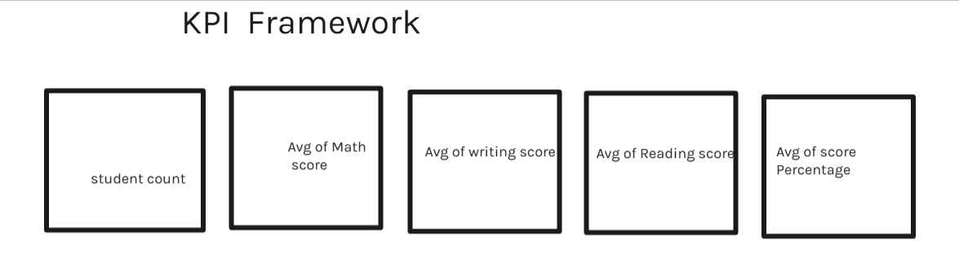
Figure 2: Core KPI cards designed for the final student Perfomance Analysis dashboard

5. Calculated Columns Used in the Project
Calculated Column | Purpose
Performance Level | Group students into categories like High Performer, Average Performer, Low Performer based on overall score
Math Score Bucket | Classify math scores into ranges such as Poor, Average, Good, Excellent
Reading Score Bucket | Classify reading scores into ranges such as Poor, Average, Good, Excellent
Writing Score Bucket | Classify writing scores into ranges such as Poor, Average, Good, Excellent
Overall Score Bucket | Group overall average score into performance bands for easier analysis
Test Preparation Status Label | Create a readable label such as Prepared / Not Prepared
Parental Education Level Group | Group parental education into categories like Educated (Bachelor/Master) and Basic Education
Gender Label | Create a clean label for gender representation (Male / Female)
Top Performer Flag | Identify top-performing students (e.g., Top 5 or above certain score threshold)
Below Average Flag | Identify students scoring below average for performance tracking

6. Dashboard Visual Building with These Measures
After measures and supporting columns were created, the final dashboard visuals were built. The visuals were selected based on the business questions and KPI needs identified in earlier weeks.
Visual | Fields / Measures Used | Purpose
KPI Cards | Total Students, Avg Math Score, Avg Reading Score, Avg Writing Score, Overall Avg Score | Provides quick summary of overall student performance
Bar Chart | Ethnicity vs Avg Score | Compare performance across different ethnic groups
Bar Chart | Gender vs Avg Score | Analyze performance difference between male and female students
Bar Chart | Parental Education vs Avg Score | Understand impact of parental education on student performance
Donut Chart | Test Preparation Status (Completed vs Not Completed) | Show distribution of students based on preparation
Column Chart | Test Preparation vs Avg Score | Compare performance of students who completed preparation vs not
Clustered Column Chart | Ethnicity vs Parental Education vs Avg Score | Analyze combined effect of ethnicity and parental education
Table | Student ID, Math Score, Reading Score, Writing Score, Total Score | Display detailed student-level data
Top N Table | Top 5 Students by Total Score | Highlight highest-performing students
Slicers (Filters) | Gender, Ethnicity, Parental Education, Test Preparation | Enable interactive filtering and deeper analysis

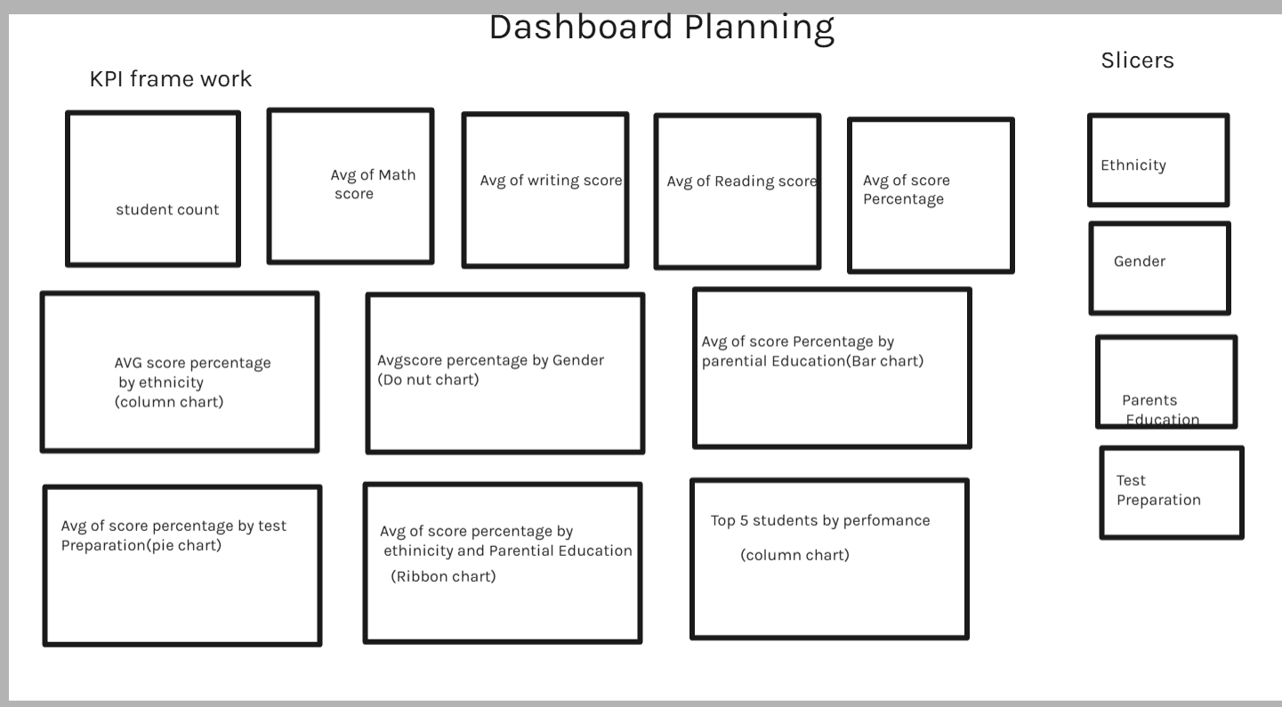
Figure 3: Example layout used for the final dashboard page design

7. Slicers, Filters, and Drill-Down
To make the dashboard interactive and user-friendly, slicers and filtering options were added. These features allow users to explore student performance based on different factors and gain deeper insights.
- Recommended slicers: Gender, Ethnicity, Parental Education, and Test Preparation
- Dropdown slicers are used for fields with multiple categories like Parental Education
- Horizontal slicers are used for small fields like Gender and Test Preparation
- Filters help users focus on specific groups of students for detailed analysis
- Chart-level filters are used to highlight specific comparisons when required

8. Interactions, Formatting, and Dashboard Storytelling
A well-designed dashboard should not only display data but also communicate insights clearly.
The followingdesign principles were applied:
- KPI cards are placed at the top for quick understanding of overall performance
- Performance comparison visuals (gender, ethnicity, preparation) are placed in the middle
- Detailed and diagnostic visuals (parental education, top performers) are placed in the lower section
- Consistent fonts, colors, and alignment are maintained across the dashboard
- Avoided unnecessary visuals to keep the dashboard clean and readable
- Used simple and business-friendly titles instead of technical names
- Controlled visual interactions to avoid confusing filtering between charts

9. Questions Answered by the Dashboard
1. How many total students are included in the dataset?
2. What is the overall average performance of students?
3. How do students perform in math, reading, and writing?
4. Does gender influence student performance?
5. How does ethnicity impact student scores?
6. What is the effect of parental education on student performance?
7. Do students who complete test preparation perform better?
8. What percentage of students completed test preparation?
9. Who are the top-performing students?
10. Which group of students performs below average?
11.How does performance vary when combining factors like ethnicity and parental education?
12. Can performance trends be analyzed using different filters?

10. Difficulties Faced While Creating the Dashboard
During the creation of the final dashboard, several practical challenges were encountered. These difficulties are normal in real-world analytics projects and helped strengthen the understanding of Power BI development.
- Single flat table made professional modeling more difficult compared to a multi-table schema
- Some columns required careful data type correction before DAX worked correctly
- Handling blanks in resolution_time_hours and ticket_resolved_date needed business logic
- Choosing whether to use measures or calculated columns for some classifications required careful decision-making
- Some visuals became cluttered when too many categories were shown together
- Controlling visual interactions required testing to avoid confusing cross-filter behavior
- Time intelligence required a proper Date table instead of relying only on raw date fields
- Balancing technical completeness with clean dashboard design was a challenge
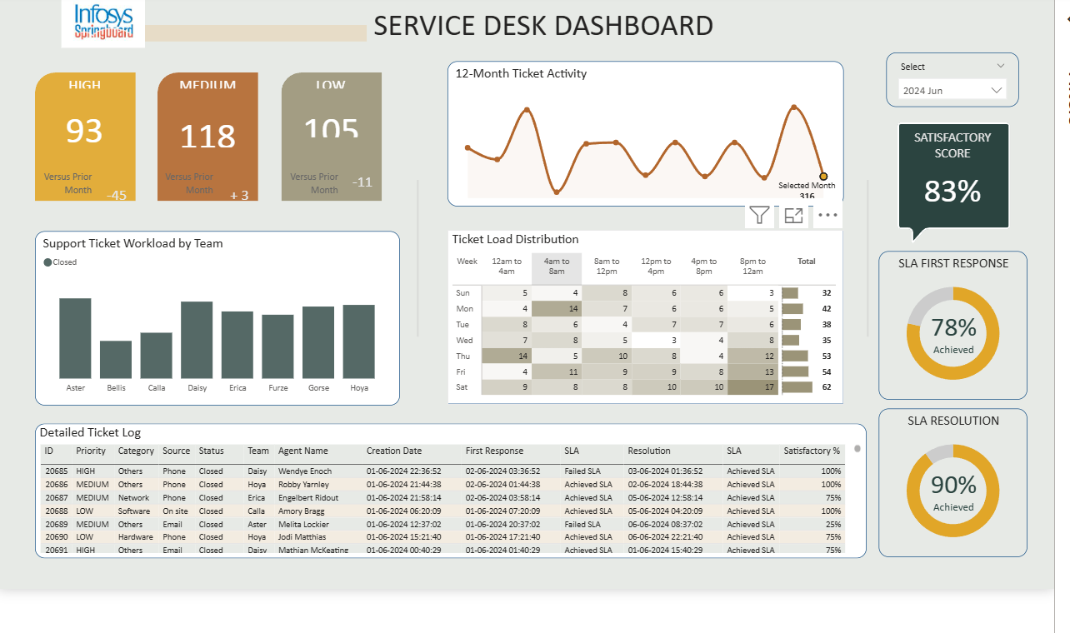

13. Final Business Value of the Dashboard
The final dashboard provides value by converting raw student data into meaningful insights. It helps educators and institutions understand student performance patterns and identify key factors that influence academic outcomes.
- Helps monitor overall student performance across subjects
- Identifies performance differences based on gender and ethnicity
- Highlights the impact of parental education on student scores
- Shows the effectiveness of test preparation on improving performance
- Supports decision-making for improving student learning strategies
- Provides a structured system for analyzing and tracking academic performance

14. Week 8 Final Learning Summary
Week 8 focused on combining all the concepts learned throughout the project into a complete analytical solution. DAX measures were created using the student dataset to calculate averages, totals, and comparisons. KPI measures were designed to provide a quick overview of student performance.
Calculated columns were added to group students into performance categories and simplify analysis. These elements were then used to build the final Power BI dashboard with interactive visuals, slicers, and filters.
This phase also highlighted practical challenges such as handling data preparation, selecting the right calculation methods, managing visual interactions, and designing a clean and understandable dashboard.
Overall, this project demonstrates how data analysis can be used to understand student performance and support better educational decisions.

15. Conclusion
This project represents the successful transformation of a raw student performance dataset into a professional Power BI dashboard. By applying DAX, creating KPIs, using calculated columns, and designing interactive visuals, the dashboard provides clear insights into student performance.
The main objective of the project was to analyze how different factors like gender, ethnicity, parental education, and test preparation affect student scores. The dashboard successfully highlights these relationships and supports data-driven decision-making.
This analytical solution can help educators identify areas for improvement, focus on student support strategies, and enhance overall academic performance.

